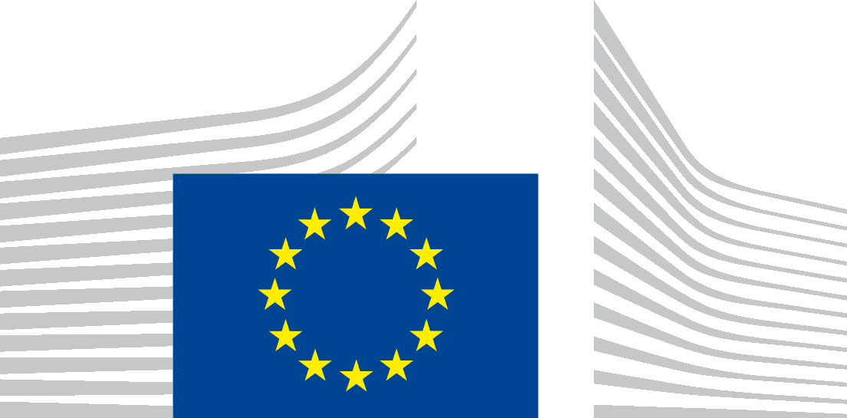 | EUROPEAN COMMISSION  DIRECTORATE-GENERAL FOR RESEARCH & INNOVATION  Directorate B - Innovation Union and European Research Area  B.5 - Spreading excellence and widening participation

INFODAY

Spreading Excellence and Widening Participation in Horizon 2020

Monday, 18 June 2018
14.00 – 17.30
Madou Tower (1, Place Madou, B-1210 Brussels), Auditorium

Draft Agenda
14:00 Registration

14:30 Welcome address
Jean-David MALO (tbc), Director, European Commission, DG Research and Innovation (RTD)

14:40 Widening - general overview
Magda DE CARLI, Head of Unit, DG RTDB.5

15:00 Lessons learnt from Widening calls (2014-17)
Peter Van der ZANDT, Head of Unit, REA B.5

15.15 The 2018 ERA Chairs and Twinning calls
Joao ALBUQUERQUE, Policy Officer, DG RTD

15:45 ERA Chairs in Estonia
Kristin KRAAV , Widening NCP, Estonia

16:00 Portugal and Twinning
José Antão, Widening NCP, Portugal

16.15 Coffee break

16.30 Opportunities provided by COST
Adeline KROLL, Policy Officer, DG RTD

16.45 Presentation from the Widening NCP network
Ms Katarzyna WALCZYK (Polish NCP)

17:00 Questions and conclusions

17:30 End of meeting

